OU-UCL collaboration proposal
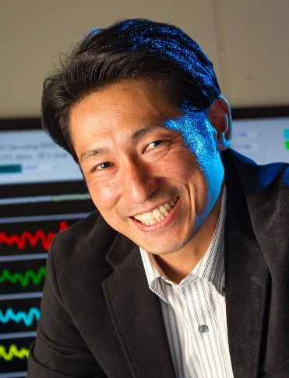  Photo | Type of collaboration (research /education /others) and theme:  Challenge to Early-stage Detection of Dementia using A Simple Patch-type Electroencephalogram (EEG: Brain Wave) Monitoring System
 | Name: Tsuyoshi Sekitani
Affiliation and position:
The Institute of Scientific and Industrial Research, Professor

Short biography and publications (up to three)
Tsuyoshi Sekitani received his B.S. from Osaka University in 1999, and Ph.D. from the Department of Applied Physics, School of Engineering, at the University of Tokyo, Japan, in 2003. From 2003 to 2010, he was an Assistant Professor, and in 2011, he was an Associate Professor in the School of Engineering at the University of Tokyo. In 2014, he was made a Full Professor in The Institute of Scientific and Industrial Research at Osaka University. In 2017, he was awarded as the title of Osaka University Distinguished Professor. He was awarded as IEEE Paul Rappaport Award in 2009 and 2010, “Highly Cited Researchers” (The World’s Most Influential Scientific Mind) from THOMSON REUTERS in 2014, Young Scientist Award from the Ministry of Education, Culture, Sports, Science and Technology, Japan in 2015, and The Japan Society for the Promotion of Science Award in 2016.
1. Tsuyoshi Sekitani, et. al., “Ultraflexible organic amplifier with biocompatible gel electrode”, Nature Communications Vol. 7, 11425 (2016).
2. Tsuyoshi Sekitani, et. al., “Flexible organic transistors and circuits with extreme bending stability”, Nature Materials Vol. 9, pp. 1015-1022 (2010).
3. Tsuyoshi Sekitani, et. al., “Rubber-like stretchable active matrix using elastic conductors”, Science Vol. 321, pp. 1468-1472 (2008).
Proposal
Osaka University (Team led by Prof. Tsuyoshi Sekitani) and the start-up company, PGV Inc. will provide an imperceptible, high-sensitivity, multi-channel, patch-type EEG sensor system that can monitor the brain activities in real time with a precision comparable to that of existing heavy medical installations (Neurofax; NIHON KOHDEN CORPORATION), merely by attaching the sensor to the forehead.
In close cooperation with doctors in UCL (the Departments of Psychiatry), we will contribute to the elucidation of the brain activities in clinical practice by quantitative measurement of the factors related to depression, healthy aging, dementia, and developmental disorders. The final goal is to realize a remote medical diagnosis system and “Brain Seff-care at home” using the patch-type EEG sensor system.
During the project period, we will ask the doctors in the Department of Psychiatry at UCL and Osaka University Graduate School of Medicine, simaltaneously in UK and Japan for comparison, to use the system and compare the measurement precision of our system with that of the existing EEG monitoring system through actual EEG monitoring of patients. Furthermore, the internatinal differences on brain activities will be studied and the medical usability of the system will be demonstrated through the clinical applications in UCL.

